

INDUSTRIAL INTERNSHIP REPORT
PROJECT TOPIC: | Data Analytics & Automation in Coal Bed Methane Operations
SUBMITTED BY: | Starina Phillips (1st year–2ndSemester)
COURSE: | M.Tech – Computer Science Engineering
UNIVERSITY: | Christ University, Bangalore
UNDER THE  GUIDANCE OF: | Mr. Vivek K. Agrawal (General Manager)
TEAM MEMBERS: | Mayank Sharma | Aprajita Rajput
DURATION: | 6 April 2026 – 7 May 2026
AT: | Reliance Industries Limited (RIL), Coal Bed Methane (CBM) Lalpur, Shahdol, M.P.

Signature: _______________________

DECLARATION

I, Starina Phillips, student of M.Tech – Computer Science Engineering ,2nd Semester atChrist University,Bangalore, hereby declare that this Industrial Internship Report titled “Data Analytics & Automation in Coal Bed Methane Operations” is an authentic record of work carried out during my internship at Reliance Industries Limited (RIL), Coal Bed Methane (CBM) Division, Shahdol, Madhya Pradesh, from 6 April 2026 to 7 May 2026.
The projects, tools, and dashboards described in this report were independently conceived, designed, developed, and tested by me under the guidance of Mr. Vivek K. Agrawal, RIL CBM Lalpur.
All data used in development and testing belongs to Reliance Industries Limited and was handled in strict compliance with the organisation's data security and confidentiality requirements. The project applications were developed in line with company requirements, and no data was transmitted to any external system or cloud service.

Starina Phillips
M.Tech CSE | 2nd Semester | Christ University, Bangalore
Data Analytics Intern, RIL CBM Lalpur | May 2026

Countersigned:
Mr. Vivek K. Agrawal | General Manager
Reliance Industries Limited, CBM Division, Shahdol

DETAIL | INFORMATION
Intern Name | Starina Phillips
Course | M.Tech CSE –First Year (2nd Semester)
Institution | Christ University, Bangalore
Period | 6 April 2026 – 7 May 2026 (1 Month)
Organisation | Reliance Industries Limited – CBM Lalpur Division, Shahdol, M.P.
Guided By | Mr. Vivek K. Agrawal
Team Members | Mayank Sharma, Aprajita Rajput

ACKNOWLEDGEMENT
I am deeply grateful to Reliance Industries Limited (RIL), Coal Bed Methane Division, Shahdol, Madhya Pradesh, for providing me this valuable opportunity to undertake my Industrial Internship in their operations and analytics department. This experience has been immensely enriching and has significantly contributed to my technical and professional development.
I would like to extend my sincere gratitude to Christ University, Bangalore, for facilitating this remarkable opportunity to undertake my industrial internship under their esteemed academic programme.
I also wish to express my deep appreciation to Reliance Industries Limited, Shahdol, for permitting me to undergo training in the data analytics and operations department. I acknowledge with gratitude the significant contributions and unwavering support of Mr. Vivek K. Agrawal, whose guidance was instrumental throughout every project undertaken during this period.
A special thanks to my team members, Mr. Mayank Sharma and Mrs. Aprajita Rajput, for their continuous collaboration and guidance. Their dedicated efforts and insightful inputs were crucial in helping us achieve our goals and deliver production-quality tools within the internship timeline.

Starina Phillips
Data Analytics Intern | RIL CBM Lalpur |April–May 2026

PREFACE

This document presents the internship report conducted at CBM – Reliance Industries Limited (RIL), Shahdol, as part of my training as a Data Analytics Engineer. It encompasses key chapters that elaborate on the various aspects of the experiences gained throughout the internship period. The report provides essential information about the training establishment, a detailed account of the training received, and an overall evaluation of the internship experience.

The initial chapters offer a comprehensive introduction to the project topic and an overview of the company. These chapters also include a brief review of the methodology used across all Three projects developed during the internship.

The subsequent chapters detail the technical experience gained during the internship. The technical tasks undertaken, the technologies explored, and the challenges encountered are discussed in depth. Tool architecture, application screenshots, code structure, and the results achieved are presented within these sections.

In the final chapters, the interpretation of results is discussed and recommendations for best practices and future research are provided. References are also provided to acknowledge the sources used throughout the report.

This comprehensive report aims to encapsulate the knowledge and skills acquired during the internship at CBM – RIL, Lalpur, Shahdol, and to reflect on the professional growth achieved during this period.

ABBREVIATIONS
ABBREVIATION | FULL FORM
AI | Artificial Intelligence
API | Application Programming Interface
CBM | Coal Bed Methane
CSV | Comma-Separated Values
DAX | Data Analysis Expressions
ETL | Extract, Transform, Load
GGS | Gas Gathering Station
GWR | Gas-Water Ratio
HDPE | High-Density Polyethylene
IDE | Integrated Development Environment
JSON | JavaScript Object Notation
KPI | Key Performance Indicator
MIS | Management Information System
ML | Machine Learning
PBI | Power BI
RIL | Reliance Industries Limited
RMSE | Root Mean Squared Error
RPM | Revolutions Per Minute
SCMD | Standard Cubic Metres per Day
SCADA | Supervisory Control and Data Acquisition
SHPPL | Shahdol–Phulpur Pipeline
TVD | True Vertical Depth

CONTENTS

1. Introduction 2. About the Organisation
2.1 Reliance Industries Limited
2.2 CBM Operations – Lalpur
2.3 Data Analytics Role in CBM

3. Technology Stack & Development Environment 4. Data Analytics Projects
4.1 Project 1 – Power BI Gas Production Monitoring Dashboard
4.1.1 Objective
4.1.2 Dashboard Architecture
4.1.3 Slicer Configuration
4.1.4 KPI Cards and DAX Measures
4.1.5 Workflow
4.1.6 Output and Impact
4.1.7 Challenges and Future Improvements
4.2 Project 2 – Power BI Positive / Negative Performance Analysis
4.2.1 Objective
4.2.2 Performance Classification Framework
4.2.3 Dashboard Architecture and Workflow
4.2.4 Output and Impact
4.2.5 Challenges and Future Improvements
4.3 Project 3 – CBM AI Hidden Pattern Detection System
4.3.1 Objective
4.3.2 System Architecture
4.3.3 Feature Engineering
4.3.4 Models and Algorithms
4.3.5 Smart Alerts and Output
4.3.6 Output and Impact
4.3.7 Challenges and Future Improvements

5. Learning Outcomes

6. Site Visit

7. Conclusions

8. References

LIST OF FIGURES
Figure4.1: Gas Production Monitoring Dashboard
Figure4.2: CBM Project Potential & Production Analysis
Figure4.3 CBM Project Hidden Pattern Detection App
Figure4.4 CBM Project Hidden Pattern Detection Code

1. Introduction

Coal Bed Methane (CBM)
Coal Bed Methane (CBM) is a form of natural gas extracted from coal seams. Unlike conventional natural gas, which migrates from source rocks to reservoir rocks, CBM is stored within the coal itself and adsorbed onto the surface of coal particles. The extraction of CBM involves drilling wells into coal seams and reducing the pressure within the formation to release the methane gas. This process requires careful management to handle water production issues and ensure the efficient capture of methane.
CBM is considered a cleaner energy source compared to traditional fossil fuels, as it has a lower carbon footprint and helps in reducing greenhouse gas emissions. India has recognised CBM as a significant energy resource, and Reliance Industries has been a pioneer in its commercial-scale development in the Shahdol region of Madhya Pradesh. The coal seams in the Shahdol block are among the thickest and most productive in India, making it one of the most strategically important CBM assets in the country.

Deposition and Coalification Process
Coal is formed from plant material that accumulates in swampy environments and undergoes a process of burial, compaction, and heat over millions of years, known as coalification. During coalification, organic material is transformed into peat and then into various ranks of coal, ranging from lignite to anthracite, depending on the degree of heat and pressure applied. The methane generated during coalification is trapped within the coal matrix, adsorbed onto the surface of micropores within the coal structure.
Cleats, which are natural fractures within the coal, play a significant role in the permeability and gas storage capacity of coal seams. There are two primary types of cleats: face cleats and butt cleats. Face cleats are continuous fractures running parallel to each other and are the main pathways for gas flow. Butt cleats are perpendicular to face cleats and are typically less continuous. The presence, orientation, and connectivity of these cleat systems significantly impact the efficiency and economics of CBM extraction operations.

CBM Extraction Process
The CBM extraction process begins with drilling vertical or directional wells into the coal seam. Initially, large quantities of water are pumped out of the formation to reduce hydrostatic pressure – a process called dewatering. As pressure drops below the desorption pressure of the coal, methane begins to desorb from the coal surface and flows through the cleat network toward the wellbore. This dewatering phase can last several months to years before peak gas production is achieved.
Produced water is routed through the field water-handling network to designated collection and treatment systems in accordance with operational and environmental requirements. The produced gas is transported through a network of low-pressure HDPE gathering lines to Gas Gathering Stations (GGS), where it is processed, compressed, and routed onward to the pipeline network. Monitoring well performance, tracking downtime events, and managing the health of surface equipment are critical day-to-day operational activities at RIL CBM Lalpur.

Data Analytics in CBM Operations
The oil and gas industry operates in a highly dynamic environment in which timely and informed decision-making is critical. Real-time data analytics and decision-support systems enable operations teams to analyse data as it is generated and convert it into actionable operational insight. At RIL CBM Lalpur, teams manage hundreds of wells, daily event logs, engineering survey records, production datasets, and machine-monitoring data – all of which require structured and automated analytical tools.
This internship was focused on developing exactly such tools: practical, offline Python desktop applications that convert raw operational data into actionable dashboards, engineering utilities, analytical reports, and decision-support outputs without any dependence on cloud services or external networks. All six projects delivered during this internship were designed to address documented day-to-day operational challenges within the CBM environment.

2. About the Organisation

2.1 Reliance Industries Limited
Reliance Industries Limited (RIL) is one of India's largest private sector enterprises, with business operations spanning petrochemicals, refining, oil and gas exploration and production, telecommunications, retail, and renewable energy. Headquartered in Mumbai, Maharashtra, RIL is a Fortune 500 company and one of the most valuable corporations in Asia. The company is known for its world-class infrastructure, technological innovation, and operational excellence across all its business verticals.
In the energy sector, Reliance holds significant upstream oil and gas assets, including exploration blocks, producing fields, and unconventional resources such as Coal Bed Methane. RIL's upstream business is focused on safe, responsible, and efficient production of hydrocarbon resources to meet India's growing energy demands. The CBM division represents a key strategic asset in RIL's domestic energy portfolio.

2.2 CBM Operations – Lalpur
The RIL CBM block in Shahdol, Madhya Pradesh, is one of India's largest producing CBM assets. The block spans a significant area of the Sohagpur coalfield basin and has been in commercial production for several years. Operations include hundreds of active production wells organised under multiple Gas Gathering Stations (GGS), each responsible for collecting, compressing, and metering gas from a cluster of wells in its geographic zone.
The operations team at CBM Lalpur manages daily well event logging, equipment maintenance scheduling, production monitoring, and dewatering coordination. These activities generate large volumes of structured and semi-structured data stored in Excel workbooks, MS Access databases, and exported CSV files, all of which are processed locally by the analytics and operations teams.

2.3 Data Analytics Role in CBM
Data analytics at RIL CBM Lalpur covers multiple operational domains: well performance monitoring and downtime analysis, engineering lookup automation, machine-health trend review for rotating and static equipment, production analysis, and operational MIS reporting for management. The analytics function serves as a bridge between raw field data and actionable operational decisions.
All analytics work is performed on local Windows systems due to strict data security and confidentiality requirements. Python-based offline desktop tools are well suited to this environment because they provide strong data-processing capability without any dependency on cloud infrastructure, external APIs, or internet-based data transfer.

3. Technology Stack & Development Environment
All projects developed during this internship follow a strict local-only, offline-first architecture. No cloud services, external APIs, or internet-dependent components were used at any stage.

COMPONENT | DETAILS
Language | Python 3.10 / 3.13
UI Framework | Tkinter (ttk) – lightweight offline desktop GUI
Data Processing | Pandas – cleaning, filtering, aggregation, date logic
Microsoft Tool | Power Bi
Visualisation | Matplotlib, Seaborn – exploratory and result plots
Machine Learning | Scikit-learn – Isolation Forest + Local Outlier Factor +Kmeans
Graphs | Clusters,PCA,3D Reservoir, Param Weights, Events,RPM Status,Param Anomaly
Database | PyODBC (optional) – MS Access .accdb data import
IDE | Visual Studio Code
Packaging | PyInstaller – standalone .exe for field deployment
OS | Windows 10 / 11
Data Sources | Excel (.xlsx), CSV, MS Access (.accdb)

3.1 Why Python and Local-Only Tools
Python was selected as the primary development language for three key reasons: (1) its extensive ecosystem of data processing and visualisation libraries (Pandas, Matplotlib, Scikitlearn, SciPy) well-suited to the analytical requirements of CBM operations; (2) the ease of building functional desktop GUIs using Tkinter without requiring a web server or browser; and (3) its ability to produce standalone .exe files via PyInstaller for deployment to non-developer users.
The local-only constraint was non-negotiable due to RIL's data security policy. All tools store data, configurations, and outputs exclusively on the local file system. No telemetry, no external API calls, and no cloud storage are used at any point. This makes the tools safe to deploy in a restricted industrial environment where internet access may be limited or monitored.

3.2 Development Environment
All development was carried out on Windows 10/11 using Visual Studio Code as the IDE. Each project maintained its own virtual environment (.venv) with a requirements.txt file for reproducibility. Git was used for local version tracking. PyInstaller commands were tested to verify correct .exe packaging before handoff. Sample Excel and Access files were used for development testing, with real operational data used only for validation in the deployed environment.

3.3 Why Power BI
Microsoft Power BI was selected as the primary dashboard platform because it provides a rich interactive visualisation environment, supports complex DAX-based calculations, and enables nontechnical operations staff to explore data through intuitive slicers and filters. Power BI's native trendline analytics pane and time-intelligence functions were particularly well-suited to CBM production timeseries data.

4. Data Analytics Projects

4.1 Project 1 – Power BI Gas Production Monitoring Dashboard
Interactive Production Trend Dashboard for CBM Well Network Performance Monitoring

4.1.1 Objective of the Project
CBM operations teams at RIL Lalpur manage production data for hundreds of active wells distributed across multiple Gas Gathering Stations. Prior to this project, daily production data was reviewed through static Excel reports generated manually by the operations team – a process that consumed significant time and resulted in delayed identification of production anomalies and declining trends.
The objective of Project 1 was to design and deploy an interactive Power BI dashboard that consolidates daily gas production data from all active CBM wells into a single, filterable visualisation environment. The dashboard provides field managers, production engineers, and operations staff with a real-time and historical view of Gas_scmd (gas production in Standard Cubic Metres per Day) trends, enabling faster monitoring, trend identification, and data-backed decision-making.

4.1.2 Dashboard Architecture
The central visual element of the dashboard is a line chart plotting Gas_scmd on the Y-Axis against Date on the X-Axis. This time-series chart provides an immediate view of production trends over any selectable date range, with each well's production represented as a distinct series for multi-well comparison. The chart incorporates a trendline overlay to highlight the directional trajectory of production over time.
The dashboard is structured across three visual zones: a filter panel on the left with all slicers, a KPI card row across the top, and the main production chart in the central panel. A secondary table panel below the main chart displays date-wise production values for the selected filter context, enabling numeric drill-down alongside the visual trend.
DASHBOARD ELEMENT | TYPE | DESCRIPTION
Gas_scmd vs Date Chart | Line Chart | Primary production trend: Y-Axis = Gas_scmd, X-Axis = Date
Trendline Overlay | Analytics Pane | Linear / exponential trendline over selected period
Well Name Slicer | Multi-select List | Filter to one or multiple individual wells
WGS Slicer | Dropdown | Filter by Well Gathering System zone
GGS Slicer | Dropdown | Filter by Gas Gathering Station cluster
Trunkline Slicer | Dropdown | Filter by main pipeline trunkline segment
Feeder No. Slicer | Numeric / Dropdown | Filter by specific feeder pipeline number
Date Range Slicer | Slider / Calendar | Select start and end date for analysis window
KPI Card Row | Card Visuals | Summary metrics: total, average, peak, active wells
Production Table | Table Visual | Date-wise numeric drill-down for selected filters

4.1.3 Slicer Configuration
Five operational slicers enable multi-dimensional exploration of CBM production data, corresponding directly to the field hierarchy from individual well to GGS cluster to trunkline network. The slicer hierarchy allows managers at different organisational levels to view data relevant to their scope of responsibility.
SLICER | FIELD | HIERARCHY LEVEL | SELECTION MODE
Well Name | Well Name | Individual well | Multi-select
WGS | WGS | Well Gathering System zone | Multi-select
GGS | GGS | Gas Gathering Station | Multi-select
Trunkline | Trunkline | Main transmission pipeline | Multi-select
Feeder No. | Feeder_No | Feeder pipeline identifier | Single / Multi
All slicers are cross-filtered: selecting a GGS automatically narrows the available Well Name and WGS options to those within that GGS zone, providing a contextually correct drill-down without requiring manual coordination of filters.

4.1.4 KPI Cards and DAX Measures
A row of KPI cards across the dashboard header provides at-a-glance summary metrics that update dynamically for the current filter context. Each card is backed by a DAX measure calculated against the filtered production dataset.
KPI CARD | METRIC | DAX SUMMARY
Total Production | Cumulative Gas_scmd for period | SUM(Production[Gas_scmd])
Average Daily Production | Mean daily output | AVERAGE(Production[Gas_scmd])
Peak Production Day | Maximum single-day output | MAX(Production[Gas_scmd])
Active Well Count | Distinct wells producing | DISTINCTCOUNT(Production[Well Name])
Production vs Prior Period | % change vs previous window | VAR / CALCULATE variance measure
Lowest Production Day | Minimum output – flag anomaly | MIN(Production[Gas_scmd])

4.1.5 Workflow
- Data Extraction: Raw daily production data exported from the field SCADA system and consolidated in Excel workbooks by the operations team.
- Data Cleaning: Missing values, duplicate records, and erroneous sensor readings identified and resolved in Power Query Editor within Power BI Desktop.
- Data Modelling: Relationships between the production fact table and dimensional tables (well hierarchy, date table) established in the Power BI data model view. A dedicated date dimension table was created for time-intelligence DAX functions.
- DAX Measures: Custom DAX measures written for all KPI cards, trendline calculations, and period-comparison metrics.
- Dashboard Design: Visualisations, slicers, and KPI cards arranged in an intuitive layout. Conditional formatting applied to highlight periods of significant production decline.
- User Review: Dashboard reviewed with field engineers for accuracy, usability, and completeness of filtering options. Feedback incorporated in final version.

4.1.6 Output and Impact
METRIC | RESULT
Monitoring time (before) | 2–3 hours daily (manual multi-sheet Excel review)
Monitoring time (after) | Under 15 minutes using interactive dashboard
Efficiency gain | 75–85% reduction in daily production review time
Anomaly detection | Same-day identification vs. 1–2 day lag with manual review
Decision support | Field managers receive ranked well performance view instantly
Trend analysis | Multi-year, multi-well trend comparison in a single view

4.1.7 Dashboard Screenshort
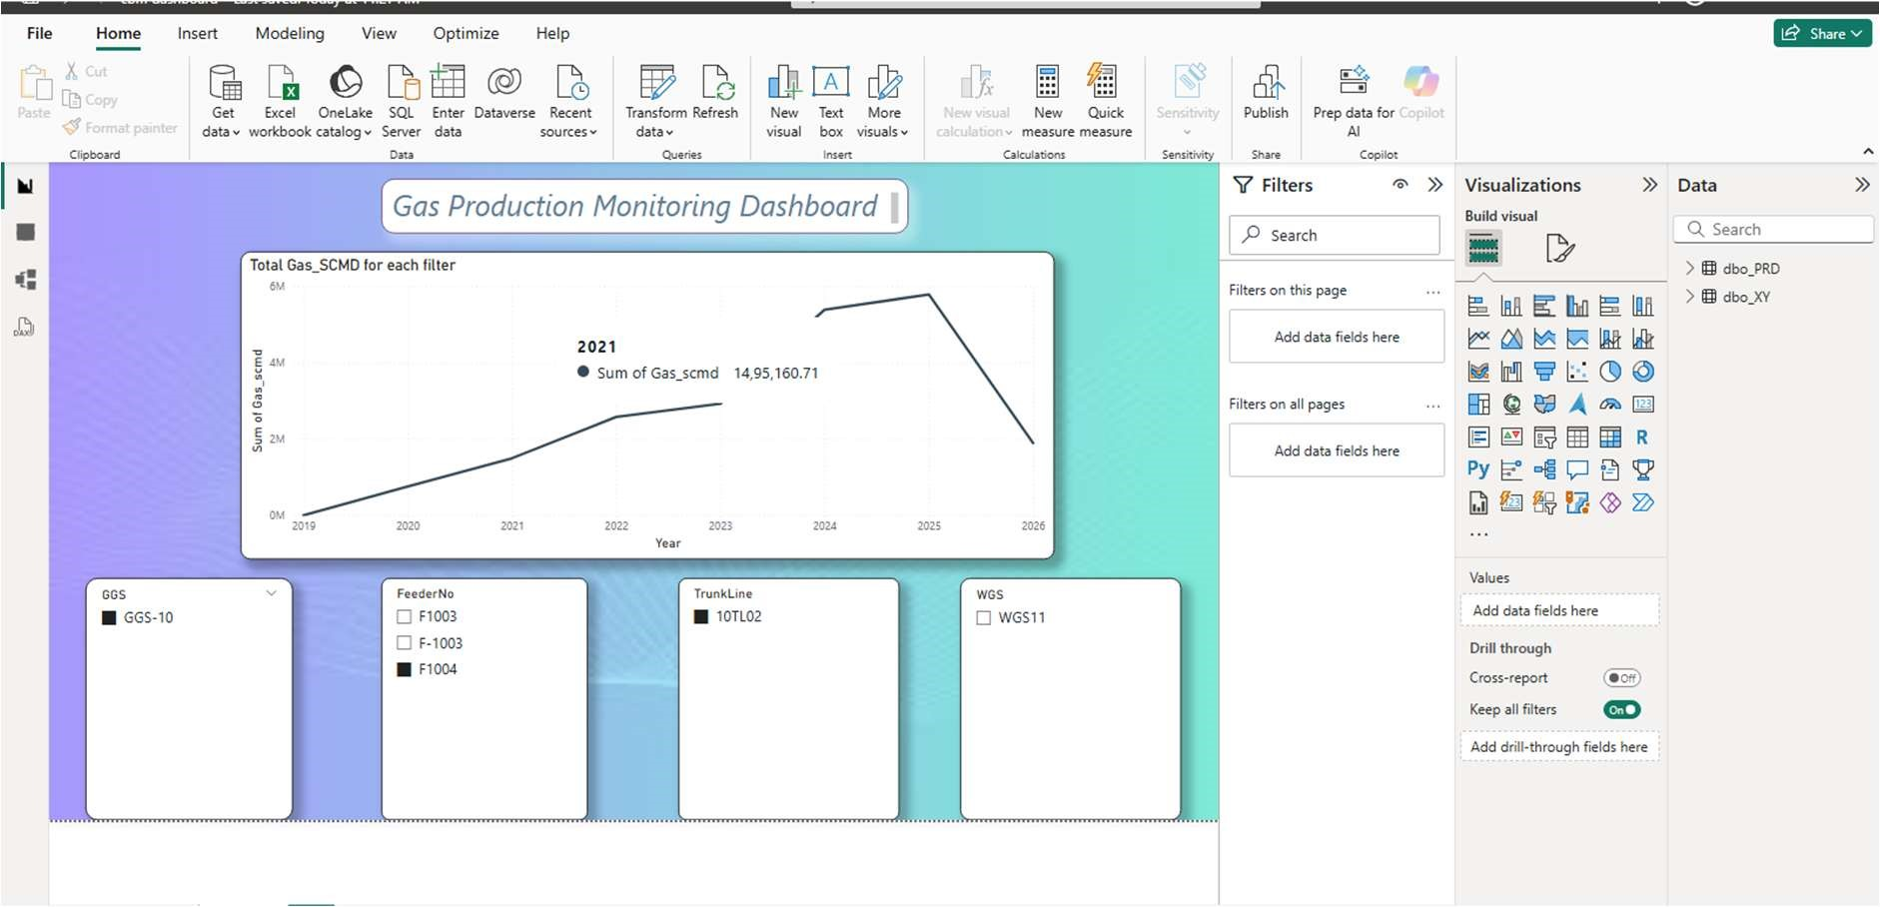
Figure4.1: Gas Production Monitoring Dashboard

4.1.8 Challenges & Future Improvements
The primary challenge was handling inconsistent date formats and missing Gas_scmd entries in source Excel exports from different GGS zones. A robust Power Query cleaning pipeline was developed to standardise all date columns and impute short gaps using forward-fill logic while flagging extended outages as operational shutdowns rather than data errors.
A secondary challenge was the performance of cross-filtered slicers on datasets spanning multiple years and hundreds of wells. DAX optimisation using calculated columns instead of complex measure filters significantly improved filter response time.
- Future: Integration with live SCADA data feeds for real-time dashboard refresh without manual export.
- Future: Anomaly detection visual layer – conditional colour coding when Gas_scmd drops below well-specific historical average thresholds.

- Future: Automated Power BI report subscription for daily distribution to GGS managers.
- Future: Mobile-optimised report layout for field access on tablet devices.

4.2 Project 2 – Power BI Positive / Negative Performance Analysis
Well Performance Benchmarking, Loss Opportunity Analysis, and Decision Support Dashboard

4.2.1 Positive vs Negative Analysis Chart
A clustered bar chart displays the average Difference value for each well, colour-coded by performance category: amber/red for Underperforming, green for Overperforming, and blue for Balanced. This chart provides an immediate ranked view of all wells by their performance gap, enabling engineers to identify the highest-priority candidates for optimisation.

4.2.2 Date-wise Performance Analysis
A time-series line chart tracks the Difference value for selected wells over time. This visualisation helps engineers determine whether underperformance is a recent development or a long-standing issue, and whether prior interventions such as pump workovers or stimulation jobs have had a measurable positive impact on production output.

4.2.3 Well-wise Ranking Table
A ranked table lists all wells sorted by their cumulative Difference over the selected reporting period, from the highest underperformance to the highest overperformance. This ranking enables production planners to prioritise engineering resources and maintenance interventions toward the wells with the greatest potential production recovery.

4.2.4 Loss Opportunity Dashboard
A dedicated dashboard panel quantifies the total cumulative production loss across the field by summing the positive Difference values across all underperforming wells and all days in the selected period. This lost production estimate, expressed in standard cubic metres, provides a compelling quantitative basis for investment decisions related to well stimulation, pump replacement, or enhanced dewatering programmes.
The workflow for this project mirrors the data pipeline established in Project 1 – production data and Well Potential values are loaded from the same source Excel file, ensuring consistency across both dashboards. The Well Potential field was sourced from the engineering well design database and added as a lookup column in the Power BI data model.

4.2.5 Output and Impact
METRIC | RESULT
Underperforming well identification | All underperforming wells identified daily, systematically, with ranked priority list
Loss quantification | Cumulative daily production loss calculated in scmd for any selected period
Before – monitoring approach | Ad hoc, irregular, dependent on individual engineer assessment
After – monitoring approach | Daily, systematic, organisation-wide – driven by automated DAX calculations

4.2.6 Dashboard Screenshot
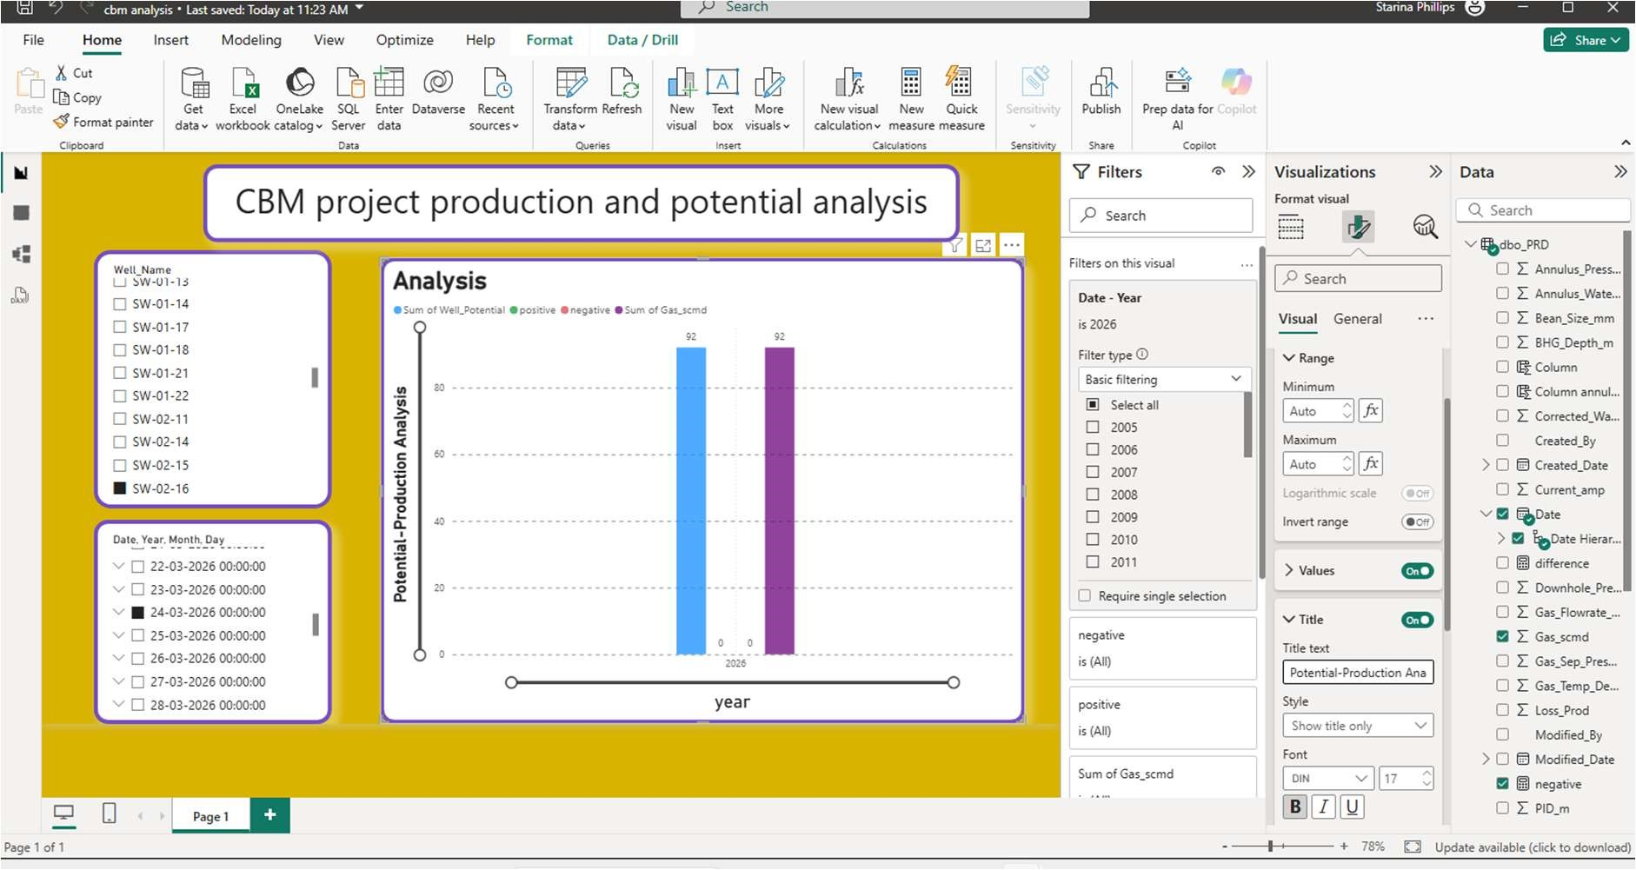Figure4.2: CBM Project Production & Potential Analysis

4.2.7 Challenges and Future Improvements
The primary challenge was sourcing accurate and consistently maintained Well Potential values from the engineering database. Well Potential figures are periodically revised following reservoir pressure assessments and re-completions, requiring a versioned data management approach to ensure the benchmarking dashboard always reflects the most current design targets.
A secondary challenge was handling wells with zero reported production (planned shutdowns vs. unplanned outages) without skewing the loss opportunity calculation with legitimate planned downtime entries.
- Future: Integration with the well event database to automatically exclude planned shutdown days from loss calculations.
- Future: Dynamic Well Potential updating from a live engineering database to reflect post-workover design revisions.
- Future: Alert generation when a well's 7-day rolling average Difference exceeds a defined threshold.
- Future: Root cause classification field linking underperformance categories to known failure modes.

4.3 Project 3 – CBM AI Hidden Pattern Detection System
Anomaly Detection, Hidden Correlation Discovery, and Predictive Analytics for CBM Well Production

4.3.1 Objective of the Project
Traditional CBM monitoring approaches rely primarily on rule-based thresholds applied to individual parameters such as Gas_scmd, pressure, or water rate. While effective for identifying obvious deviations, these approaches fail to capture complex multi-dimensional relationships between operational parameters and do not provide insights into similarity patterns across wells.
The objective of this project was to design and develop an AI-based analytics system capable of:
- Clustering wells based on multi-parameter similarity
- Detecting anomalous wells using unsupervised machine learning
- Identifying hidden relationships between operational parameters
- Providing actionable insights for production optimization
The system was implemented as a fully offline Python-based desktop application, ensuring compliance with strict industrial data security requirements.

4.3.2 System Architecture and Rule Logic
The AI system is implemented as a modular Python pipeline with four components, each independently testable and maintainable:
MODULE | RESPONSIBILITY
data_loader.py | Multi-format data ingestion (CSV, Excel, MS Access), schema detection, missing value handling
feature_engineering.py | Derived feature computation: rolling averages, lag features, GWR, pressure differentials, date components
anomaly_detector.py | Isolation Forest unsupervised anomaly scoring with rolling training window
clustering engine | K-Means clustering of wells based on selected features
aggregation engine | Conversion of raw data into well-level aggregated profiles
insight engine | Generation of anomaly insights and clustering results

4.3.3 Well-Based Aggregation Logic
Instead of performing analysis on raw row-level data, the system aggregates data at the well level to create meaningful feature representations.
Each well is transformed into a feature vector using statistical aggregation:
- Mean
- Standard Deviation
- Minimum / Maximum
- Percentiles (P25, P75) • Count
This transformation significantly reduces data volume and improves computational efficiency while preserving essential behavioural patterns.
Example:
Large dataset → Converted into well-level profiles → Enables faster and more meaningful clustering

FEATURE | SOURCE / DERIVATION | ML ROLE
Gas_scmd | Direct measurement | Primary production indicator
Well Potential | Engineering data | Benchmark reference
Difference | Derived (Potential – Actual) | Performance gap
Pressure | SCADA data | Flow condition
Water Rate | SCADA data | Dewatering indicator
Aggregated Metrics | Mean, Std, Min, Max | Behaviour representation
Encoded Well ID | Label encoding | Well identification

4.3.4 Models and Algorithms
Four complementary machine learning algorithms were employed, each serving a distinct analytical function within the pattern detection system:

K-Means Clustering
K-Means clustering is applied to well-level aggregated features to group wells based on similarity. Feature weighting is incorporated to allow domain-driven importance assignment.

Isolation Forest – Anomaly Detection
Isolation Forest is an unsupervised anomaly detection algorithm that identifies outlier observations by measuring how easily they can be isolated through random recursive partitioning. Anomalous production records – those deviating significantly from normal multidimensional operational patterns – produce shorter average path lengths in the isolation tree ensemble and receive high anomaly scores.
In the CBM context, Isolation Forest was applied to detect daily production readings that represent genuine operational anomalies without requiring pre-labelled training data. The model was configured with a contamination parameter of 0.05 (5% assumed anomaly rate) and trained on a rolling 90-day window of historical production to adapt to evolving seasonal patterns.

4.3.6 Parameter Similarity Analysis
The system performs similarity analysis to identify relationships between operational parameters using:
- Pearson Correlation Matrix
- Cosine Similarity Matrix
- Heatmap Visualizations This analysis helps in:
- Identifying redundant parameters
- Understanding feature dependencies
- Improving model accuracy through better feature selection

4.3.6 Output and Impact
METRIC | RESULT
Data reduction | Early identification of abnormal wells
Clustering insight | Wells grouped based on operational similarity
Anomaly detection | Early identification of abnormal wells
Analysis efficiency | Significant reduction in processing time

4.3.7 Application & Code
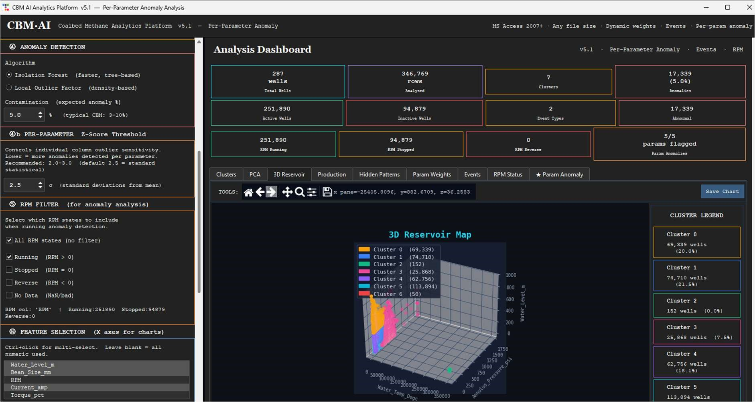
Figure4.3: CBM Project Hidden Pattern Detection App

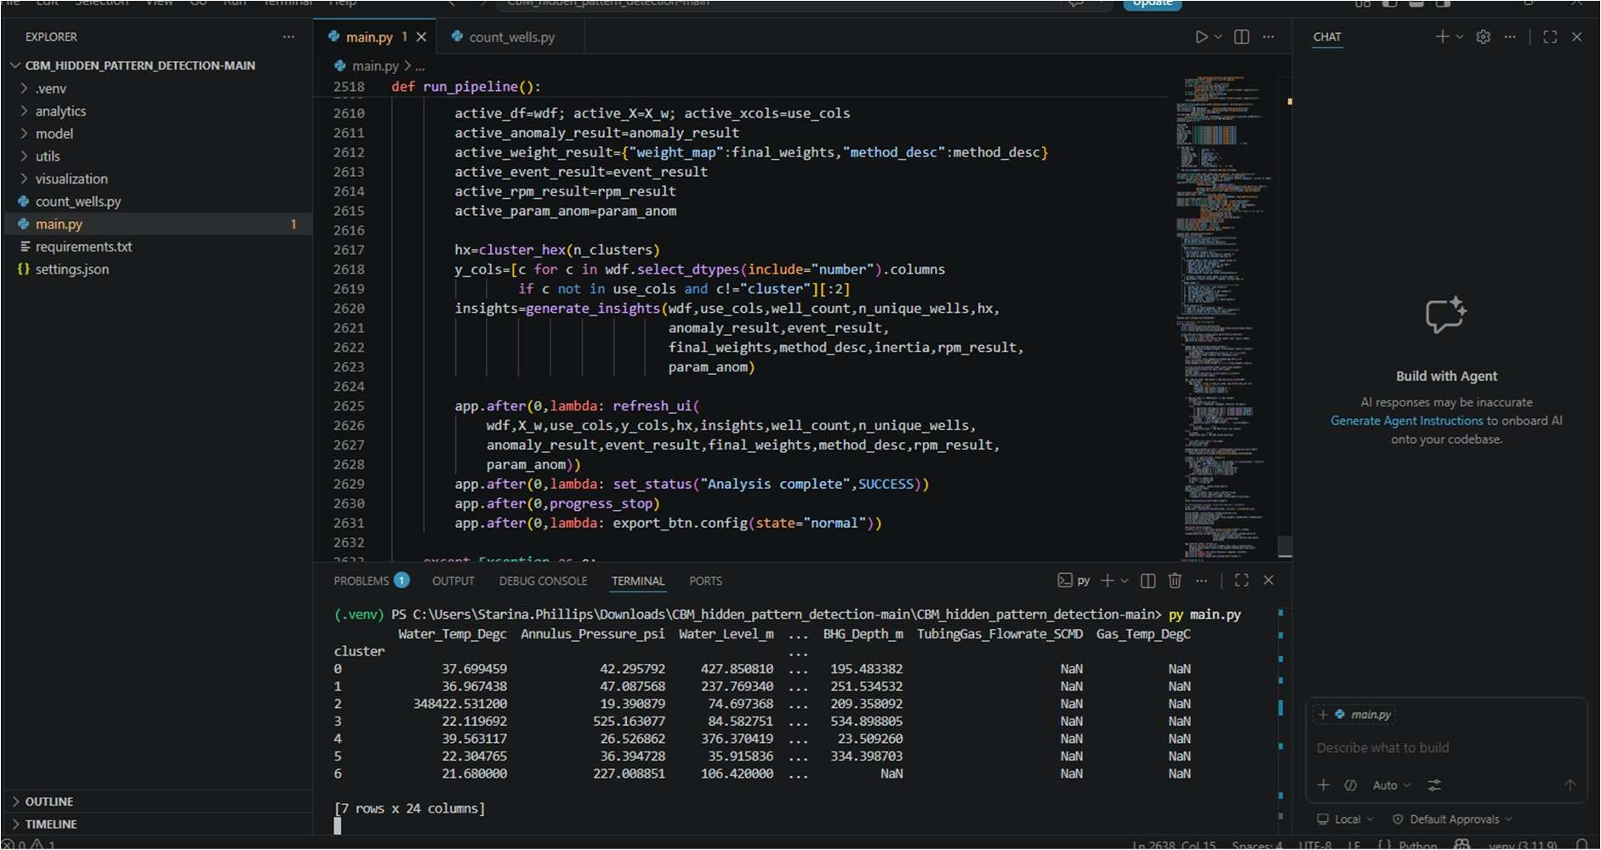
Figure4.4: CBM Project Hidden Pattern Detection Code

4.3.8 Challenges and Future Improvements
The most significant challenge was the limited availability of labelled training data for the Random Forest classifier. Historical event records were inconsistently logged across different reporting periods, requiring manual labelling of a representative training set in collaboration with the operations team. Data quality improvement in the source systems would directly benefit model accuracy in future retraining cycles.
A secondary challenge was ensuring the Isolation Forest model adapted to legitimate seasonal production changes without generating false positive anomaly alerts during known dewatering acceleration or stimulation periods. The rolling training window approach and operations team annotation of known event periods effectively addressed this issue.
- Future: Integration of downhole sensor data (pump RPM, current draw, vibration) for richer anomaly detection feature set.
- Future: Automated daily model retraining pipeline using most recent 90-day production window.
- Future: Web-based alert dashboard for operations team access without Python environment requirement.
- Future: Reinforcement learning component to learn optimal maintenance intervention timing from historical outcomes.
- Future: Extension to include wellhead pressure time-series for compressor and surface equipment anomaly detection.

5. Learning Outcomes

5.1 Technical Skills
- Production-grade Power BI dashboard development including multi-table data modelling, star schema design, DAX calculated columns and measures, and timeintelligence functions for period-over-period comparisons.
- Advanced Power Query ETL workflows for multi-source Excel and CSV consolidation, including schema normalisation, date standardisation, missing value handling, and conditional column derivation.
- Python-based machine learning pipeline development using Scikit-learn (Isolation Forest,LOF), and Prophet (time series decomposition and forecasting).
- Feature engineering for time-series industrial data: rolling statistics, lag features, ratio derivation, and categorical encoding for well identity and calendar effects.
- Model evaluation using appropriate metrics for anomaly detection (anomaly rate calibration, precision-recall) and regression forecasting (RMSE, MAE, directional accuracy).
- Data visualisation for analytical communication: Matplotlib trend plots, feature importance bar charts, confusion matrices, and actual-vs-predicted forecast plots.

5.2 Domain Knowledge
- Coal Bed Methane extraction: well lifecycle from dewatering to peak production and decline; GGS structure and well-to-pipeline flow hierarchy; well event classification and downtime categories.
- CBM production parameters: Gas_scmd measurement and reporting standards; Well Potential as an engineering benchmark; wellhead pressure and water rate as reservoir condition indicators.
- Well performance benchmarking: the Difference = Well Potential – Gas_scmd framework as an operational management tool; loss opportunity quantification for commercial decision-making.
- Industrial data governance: offline-first analytics tools; strict local data security policies; no-cloud, no-internet constraints on production-deployed analytics systems at RIL CBM Lalpur.

5.3 Professional Skills
- Translating operational business requirements from field engineers and production managers into structured analytical design specifications and working deliverables.
- Working with real, messy, industrial-grade production datasets under time constraints and in a live operational environment.
- Communicating technical solutions to non-technical operations staff and incorporating practical feedback into dashboard and model design iterations.
- Delivering three substantial projects within a two-month internship timeline while maintaining documentation and code quality.
- Understanding the professional standards and compliance requirements of working in a large industrial organisation with strict data security and operational confidentiality policies.

5.4 Key Challenges Overcome
Across the three projects, several common technical challenges were encountered and resolved:
- Inconsistent source data formats: Production data from different GGS zones and reporting periods had varying column names, date formats, and header structures. Robust Power Query and Pandas parsing pipelines were developed to handle realworld inconsistencies.
- Missing and sentinel values: Gas_scmd entries for planned shutdown days, partially online wells, and sensor outages required context-aware handling rather than simple deletion or zero-imputation.
- Well Potential baseline quality: Engineering Well Potential figures required validation and revision in collaboration with the operations team to ensure the benchmarking analysis in Project 2 reflected current design conditions.
- Labelled training data scarcity: The Random Forest model in Project 3 required historical event labels that were not consistently available in existing records. A targeted labelling exercise with the operations team produced a usable training set.
- False positive management in anomaly detection: The Isolation Forest model required careful threshold calibration and event annotation to distinguish genuine production anomalies from legitimate operational events such as planned shutdowns and stimulation campaigns.

6. Site Visit

As part of the internship, a site visit was undertaken to gain first-hand exposure to the physical workflow of Coal Bed Methane operations beyond the analytical and reporting environment. The visit provided practical understanding of wellsite infrastructure, gathering-system layout, and the downstream movement of gas from production wells to processing and transmission facilities. This field exposure helped correlate operational datasets with the actual equipment, process stages, and flow paths observed in the field.

A specific visit to GGS-11 provided insight into the Gas Gathering Station process flow. The sequence observed included receipt of methane gas from well sites, primary handling through the slug catcher, compression through the compressor unit, gas dehydration, and measurement through the custody transfer meter before onward dispatch to SHPPL. The visit also clarified how lateral lines from multiple wellsites are connected to trunk lines and routed toward GGS nodes such as GGS-10, GGS-11, and GGS-12, followed by compression and transmission. Observation of the associated wellsite arrangement, including the gas separator, water separator, water pit, drive head, PSS, VFD, and field monitoring elements, provided a practical understanding of how production and water-handling systems are integrated at ground level.

The site visit also improved understanding of the broader CBM well lifecycle and evacuation infrastructure. The well completion sequence—from land survey and civil preparation to drilling, logging, casing, cementing, perforation, hydro-fracturing, completion, production, infield transfer, processing, and final delivery—was reviewed in an operational context. In addition, exposure to the Shahdol–Phulpur Pipeline (SHPPL) helped explain the downstream connectivity of the CBM network and the role of compressor and metering stations in transferring processed gas toward the pipeline system. Overall, the site visit strengthened practical domain knowledge and provided valuable context for the engineering and analytics work documented in this report.

7. Conclusions
The One-month Industrial Internship at Reliance Industries Limited, CBM Division, Shahdol, was an exceptionally productive and professionally rewarding experience. Three operational data analytics projects were designed, developed, and documented, each addressing a real and recurring workflow challenge in the CBM environment at Lalpur.
- Project 1 – the Power BI Gas Production Monitoring Dashboard – eliminated the manual daily production review bottleneck by providing an interactive, filterable, realtime view of Gas_scmd trends across the entire well network. The dashboard reduced daily monitoring time by 75–85% and enabled same-day identification of production anomalies that previously required 1–2 days to surface through manual Excel review.
- Project 2 – the Power BI Positive / Negative Performance Analysis – introduced a systematic, formula-driven benchmarking framework comparing actual production against Well Potential on a daily well-by-well basis. The dashboard provided a ranked prioritisation of underperforming wells and quantified cumulative production losses, delivering a direct and compelling input into engineering optimisation and maintenance scheduling decisions.
- Project 3 – the CBM AI Hidden Pattern Detection System – demonstrated the value of machine learning in CBM operations analytics. The combination of Isolation Forest for anomaly detection, Local Outlier Factor for density based anomaly detection, and Prophet for long-term trend analysis produced a system capable of identifying equipment issues 5–12 days ahead of their manifestation in conventional monitoring data. The discovery of previously unrecognised lagged correlations between water rate and Gas_scmd provided new and actionable operational insight.
All three projects were designed to complement each other: Project 1 provides the operational overview, Project 2 identifies priority targets for optimisation, and Project 3 provides the predictive intelligence to guide proactive maintenance and intervention decisions. Together they form an integrated data analytics framework for CBM production management.
From a personal development perspective, this internship provided an invaluable opportunity to apply M.Tech Computer Science competencies to challenging real-world industrial problems. The experience combined applied data science, business intelligence development, and machine learning engineering within a large-scale operational environment, significantly deepening both technical proficiency and industrial domain knowledge.

7.1 Recommendations for Future Work
- Integrate the Power BI dashboards with a live SCADA data connection to enable automatic daily refresh without manual Excel export, eliminating the remaining manual data handling step in the current workflow.
- Develop automated Power BI paginated reports for daily and weekly distribution to GGS managers and field supervisors, standardising reporting formats across the CBM Lalpur operation.
- Enhance the Well Potential baseline management process by establishing a versioned engineering database that automatically updates Project 2 benchmarks following postworkover well assessments.
- Package the Python AI pipeline as a standalone Windows application (using PyInstaller) for deployment to operations team computers without requiring a Python installation, broadening the user base for Project 3 outputs.
- Extend the AI Hidden Pattern Detection system to incorporate downhole sensor data – including pump RPM, motor current, and vibration measurements – to provide richer anomaly detection feature coverage and improve early fault prediction accuracy.
- Implement an automated daily model retraining pipeline for the Isolation Forest and LOF models using a rolling 90-day data window, ensuring models remain calibrated to current reservoir and operational conditions.
- Develop a unified internal analytics portal consolidating all three project dashboards for consistent multi-user access across GGS managers, production engineers, and operations coordinators at CBM Lalpur.
- Explore integration of the Difference-based loss opportunity data from Project 2 directly into the Project 3 AI model feature set, potentially improving early detection of underperformance trajectories.

7.2 Overall Assessment
- This internship provided a rare opportunity to work on real, production-grade data problems in a large-scale industrial environment. The projects were not academic exercises – they were built to solve actual workflow inefficiencies experienced by operations engineers and field coordinators at RIL CBM Lalpur. The feedback received during dashboard reviews and testing confirmed that the deliverables significantly reduced manual monitoring effort and improved the consistency of production reporting outputs.
- From a technical perspective, the internship provided hands-on experience across Power BI dashboard development, DAX-based performance benchmarking, and Python-driven AI pattern detection – applied end-to-end on real CBM field data. The experience of working under data security constraints – no cloud, no internet, local-only – also provided a realistic understanding of industrial analytics challenges that are rarely encountered in academic projects.
- In summary, this internship at Reliance Industries Limited, CBM Division, Shahdol, has been a defining professional experience, combining applied data analytics, business intelligence development, and machine learning – all grounded in the operational realities of the CBM Lalpur environment. The three projects delivered stand as tangible evidence of the work accomplished and reflect the practical value created during the internship period.

8. References
- Microsoft Corporation. Power BI Desktop Official Documentation. https://docs.microsoft.com/en-us/power-bi/
- Microsoft Corporation. Excel User Guide and Power Query Documentation. https://support.microsoft.com/en-us/excel
- Python Software Foundation. Python 3.10 Official Documentation. https://docs.python.org
- Pedregosa, F. et al. (2011). Scikit-learn: Machine Learning in Python. Journal of Machine Learning Research, 12, 2825–2830. https://scikit-learn.org
- Liu, F.T., Ting, K.M., & Zhou, Z.H. (2008). Isolation Forest. IEEE International Conference on Data Mining, 413–422.
- Breiman, L. (2001). Random Forests. Machine Learning, 45(1), 5–32.
- Government of India, Directorate General of Hydrocarbons. Coal Bed Methane Policy and Operational Guidelines. Ministry of Petroleum and Natural Gas.
- Gondalia, V.L. et al. (2008). Coal Bed Methane: An Overview. Journal of Scientific and Industrial Research.
- Reliance Industries Limited. Annual Report 2025–26. https://www.ril.com
- McKinney, W. (2017). Python for Data Analysis, 2nd Edition. O'Reilly Media. Pandas Development Team. Pandas User Guide. https://pandas.pydata.org/docs.

